Fall Semester 2025-26
Lab Assignment – 4
Slot: L13+L14
Class: VL2025260105679
Branch: B.tech CSBS
Course code & title: CBS3005
Cloud, Microservices and Applications
Faculty name: Nithya K
DA by:
Kartikey Gupta
22BBS0105

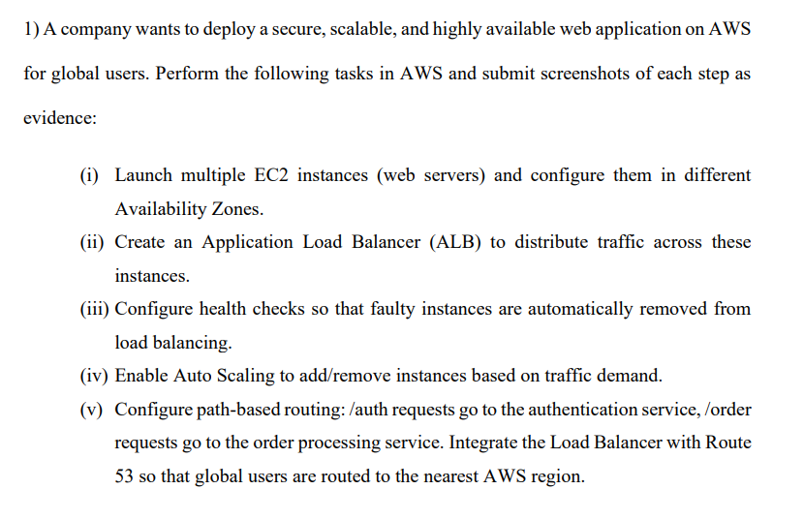

(i) Launch Multiple EC2 Instances in Different Availability Zones
- Log in to AWS Management Console → go to EC2.
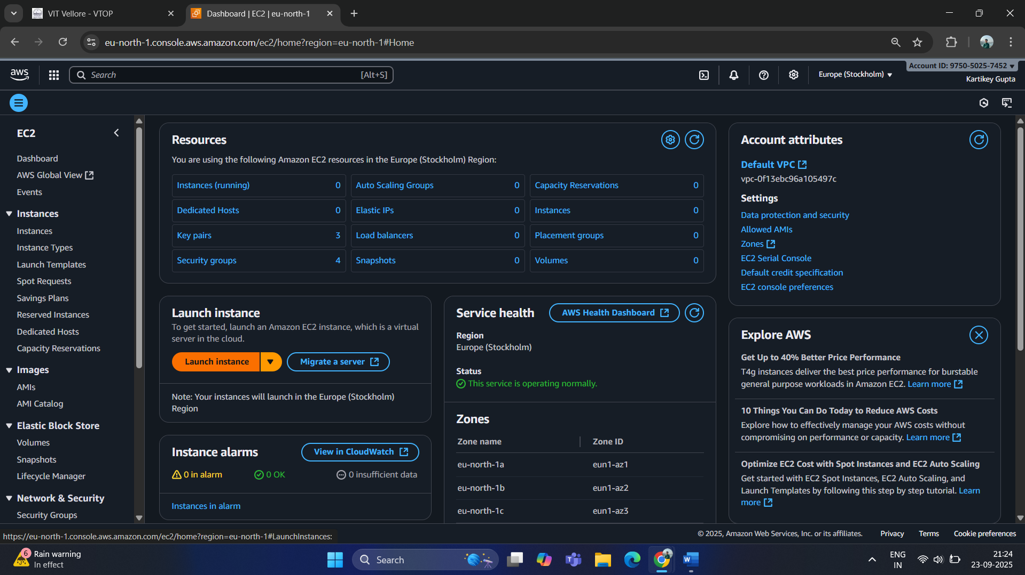
- Click Launch Instance → choose Amazon Linux 2 / Ubuntu AMI.
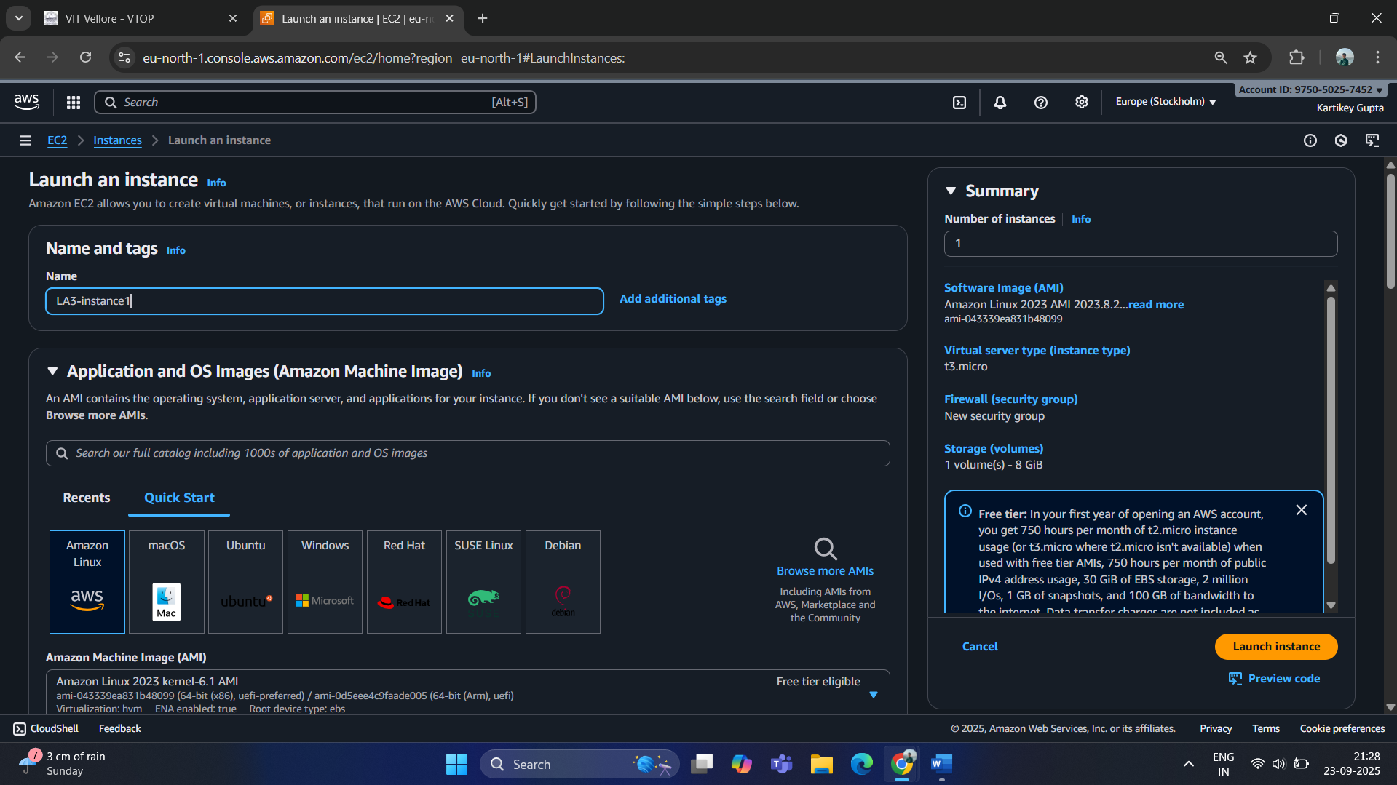
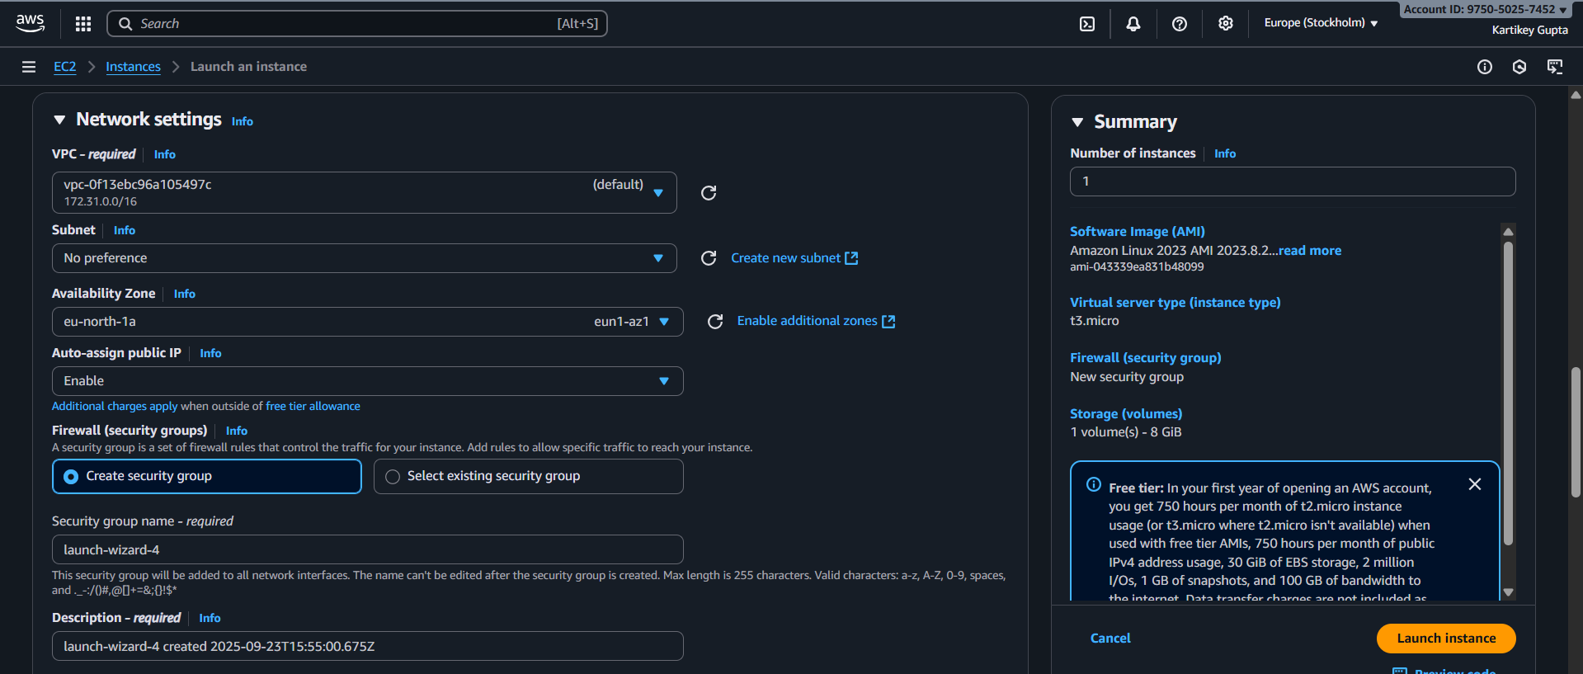
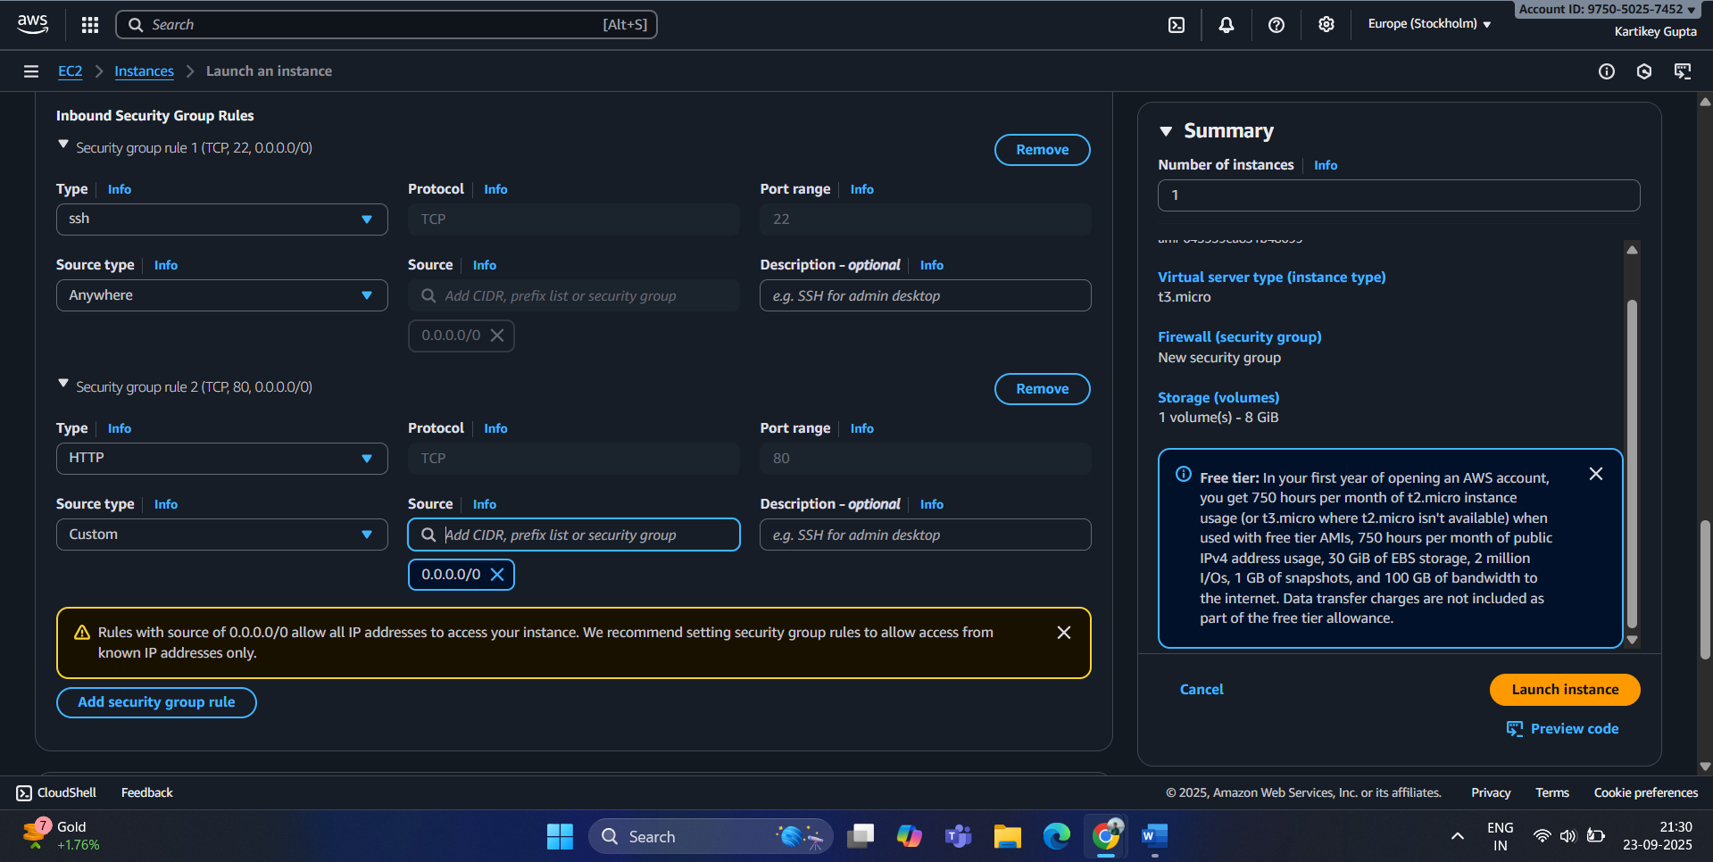
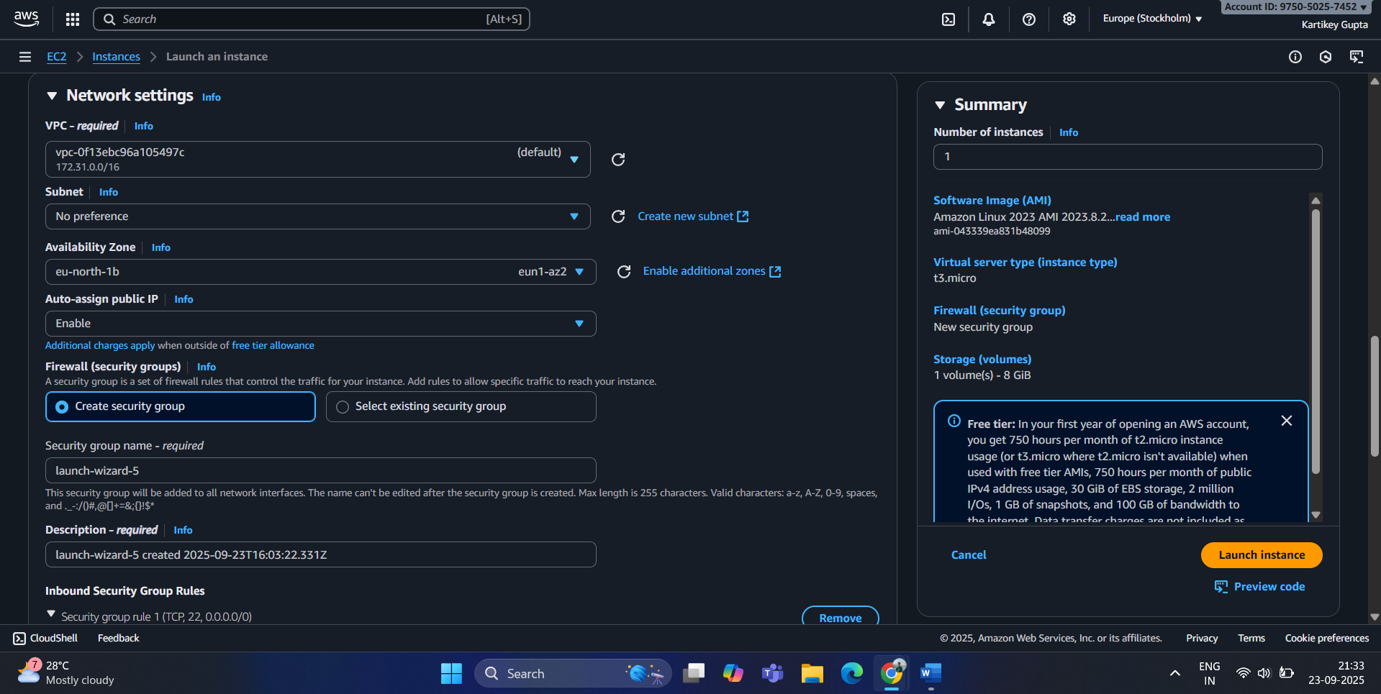
- Select an instance type (e.g., t2.micro for free tier).
- In Network settings:
  - Choose a VPC (default or custom).
  - Place Instance 1 in Availability Zone A (e.g., ap-south-1a).
  - Place Instance 2 in Availability Zone B (e.g., ap-south-1b).
- Configure Security Group:
  - Allow HTTP (port 80) and SSH (port 22).
- Launch instances and note public IPs.

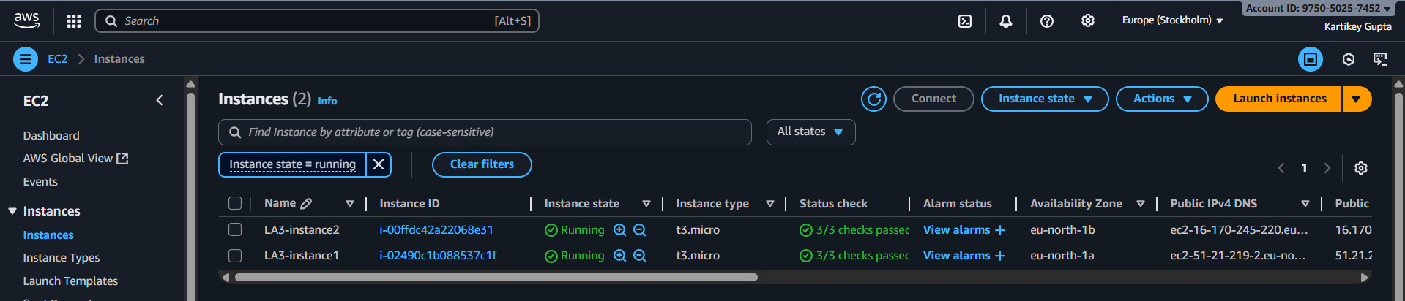

(ii) Create Application Load Balancer (ALB)

Step 1: Create Target Group(s) first
- Go to EC2 → Target Groups → Create target group.
- Configure:
  - Target type: Instances
  - Name: e.g., MyApp-TG
  - Protocol: HTTP
  - Port: 80
  - VPC: Select the same VPC where your EC2 instances are launched
  - Health check: HTTP, path /
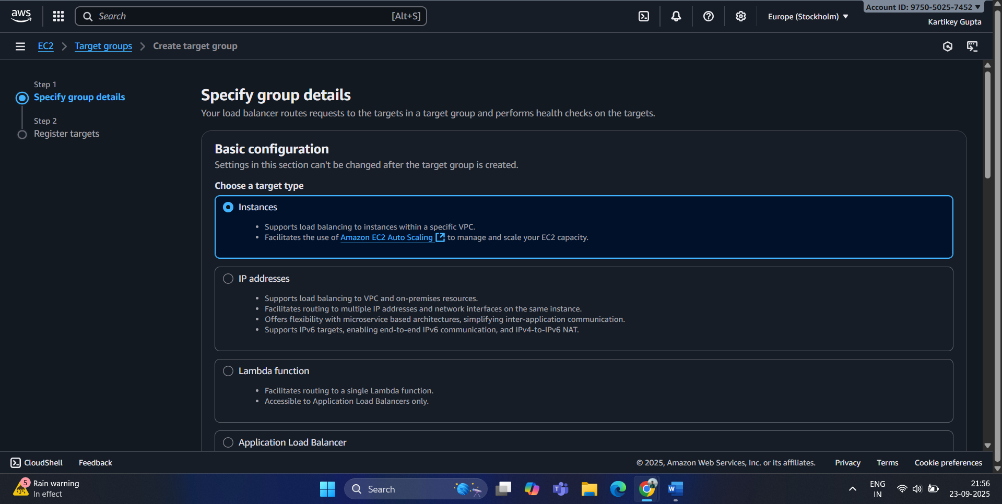
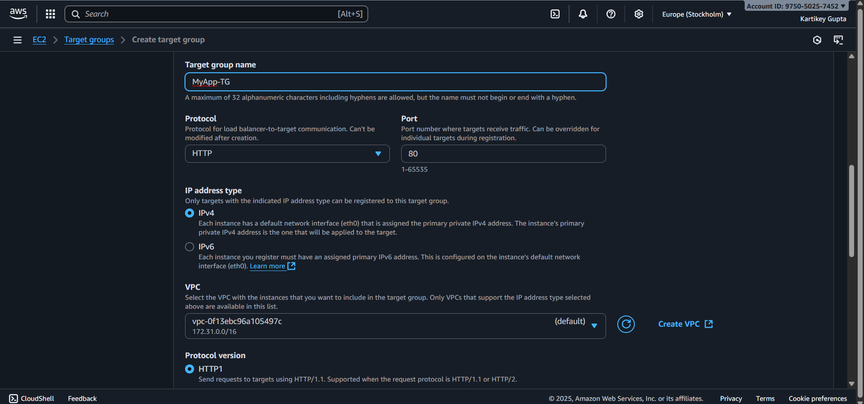
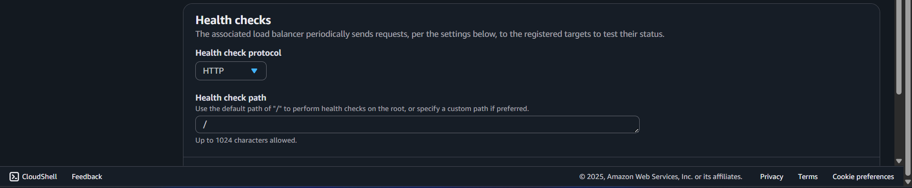
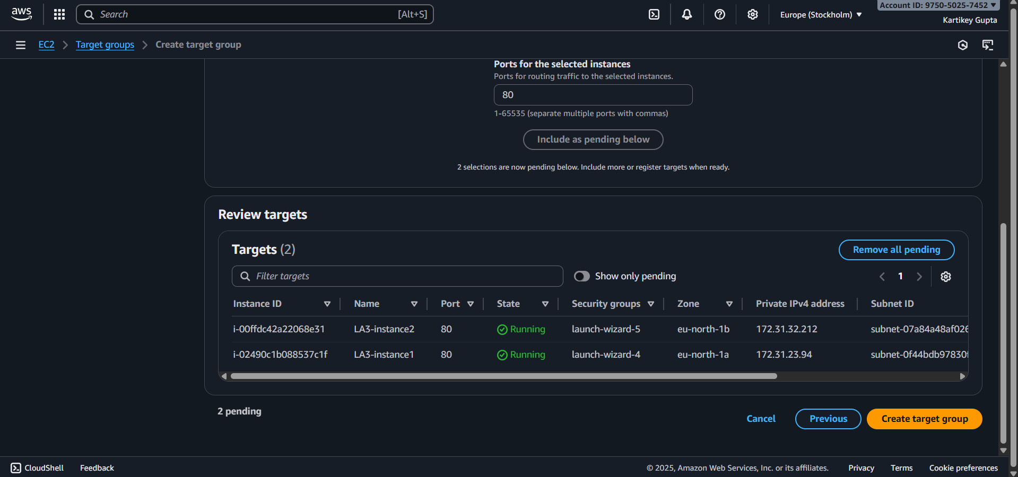
- Click Next and register your EC2 instances in this Target Group.
- Complete Target Group creation.
- Install servers
  - sudo yum update -y
  - sudo yum install -y httpd
  - sudo systemctl start httpd
  - sudo systemctl enable httpd
  - echo "Hello from $(hostname -f)" > /var/www/html/index.html

Step 2: Create ALB
- Go to EC2 → Load Balancers → Create Load Balancer → Application Load Balancer.
- Configure:
  - Name: MyAppALB
  - Scheme: Internet-facing
  - IP address type: IPv4
  - Listeners: HTTP (80)
- Select Availability Zones: choose at least 2 public subnets in different AZs.

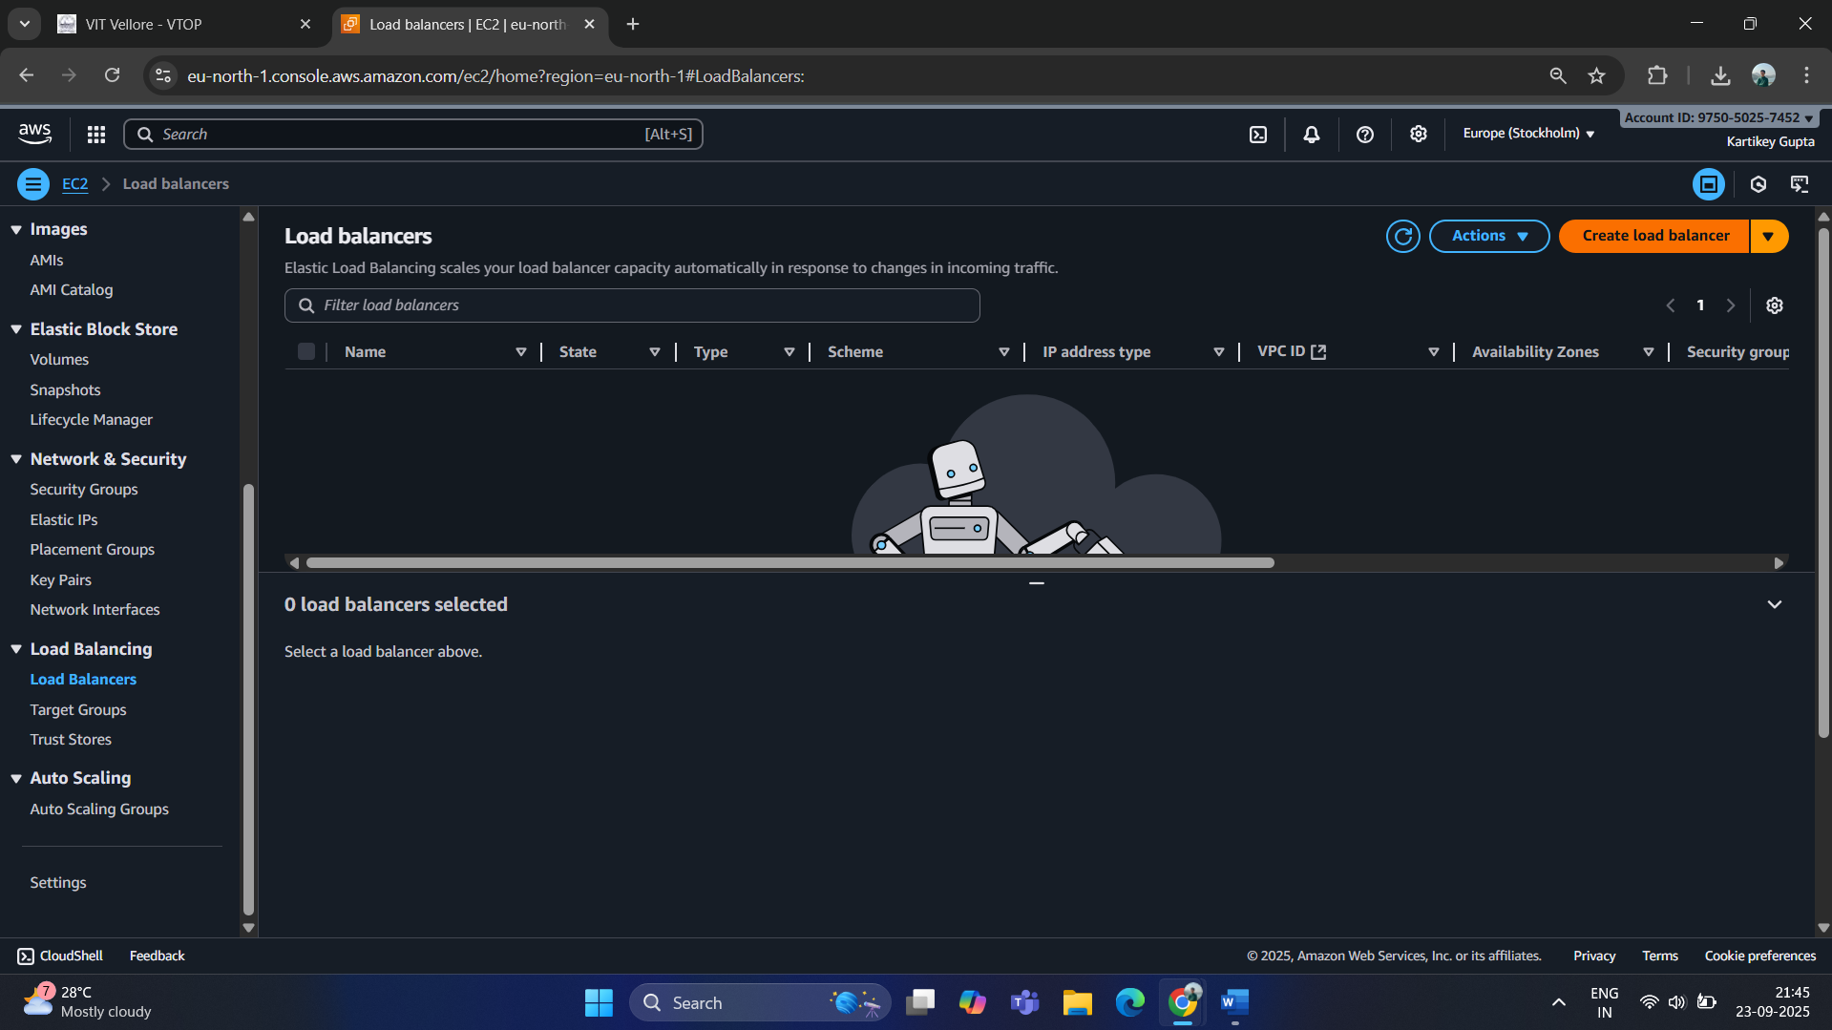
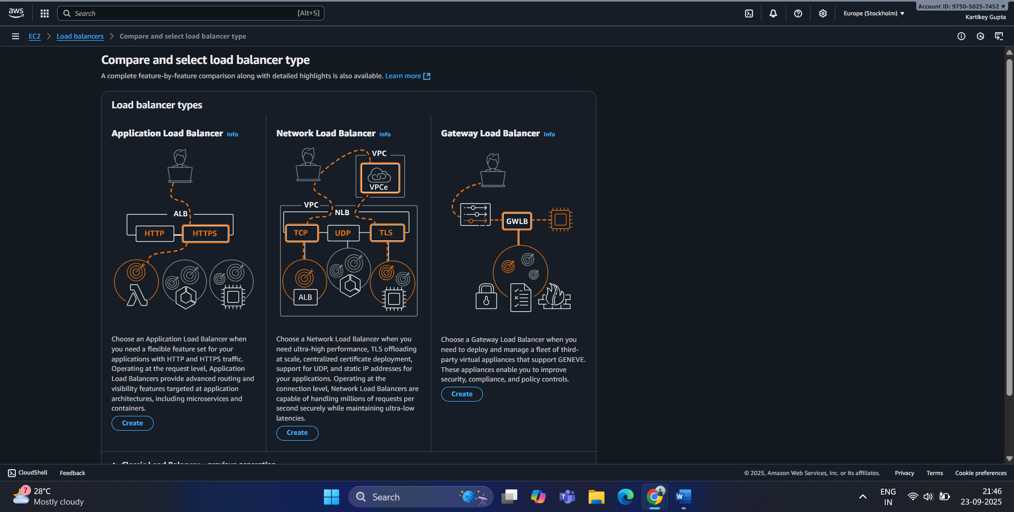
- Configure:
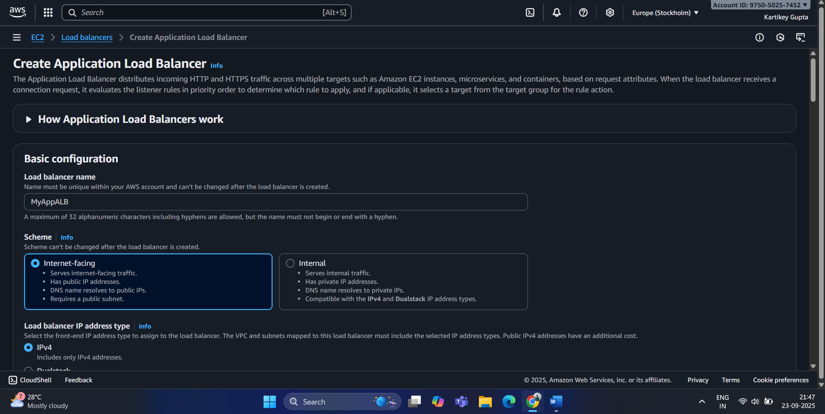
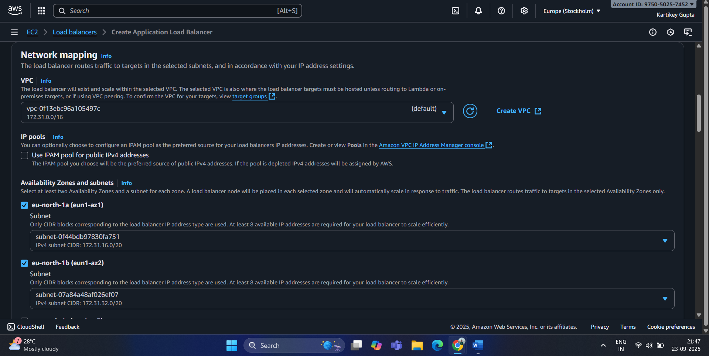
Step 3: Configure Security Group
- Either select an existing SG or create a new one.
- Inbound rule: HTTP, port 80, source 0.0.0.0/0
- Outbound can remain default (All traffic).
Step 4: Attach Target Group
- Under Listener → Default action, select Forward to → Your Target Group (e.g., MyApp-TG).
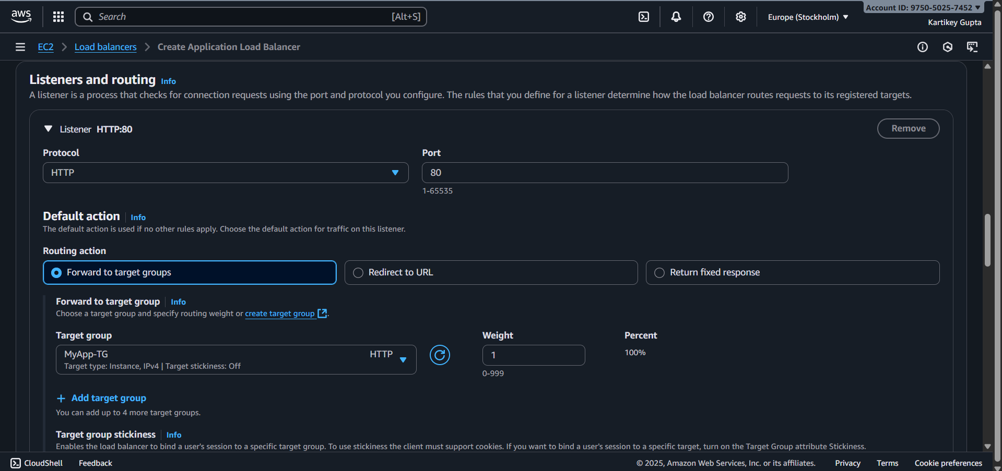
Step 5: Review and Create
- Review all settings and click Create Load Balancer.
- Note the ALB DNS name — this is what users will access.
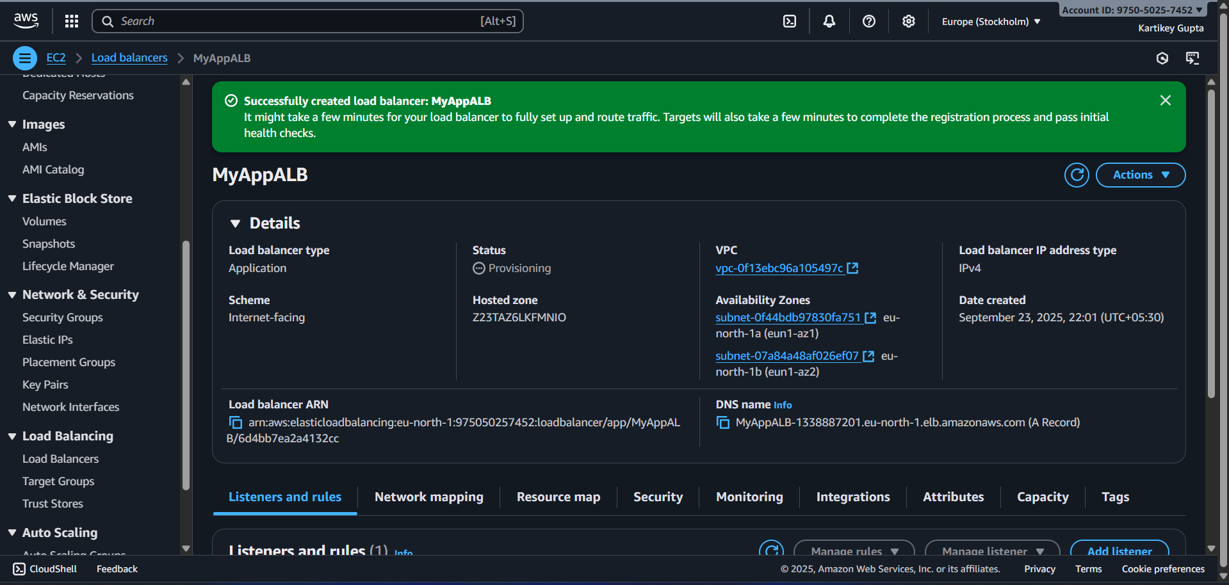

Step (iii): Configure Health Checks
Step 1: Open Target Groups
- Go to EC2 → Target Groups in the AWS console.
- Select the Target Group you created (e.g., MyApp-TG).

Step 2: Go to Health Checks
- In the Target Group details, click the Health checks tab.

Step 3: Configure Health Check Settings
- Protocol: HTTP
- Path: / (or /health if you have a dedicated health endpoint)
- Healthy threshold: 2 → instance must pass 2 consecutive checks to be marked healthy
- Unhealthy threshold: 2 → instance must fail 2 consecutive checks to be marked unhealthy
- Timeout: 5 seconds → how long to wait for a response
- Interval: 30 seconds → time between checks
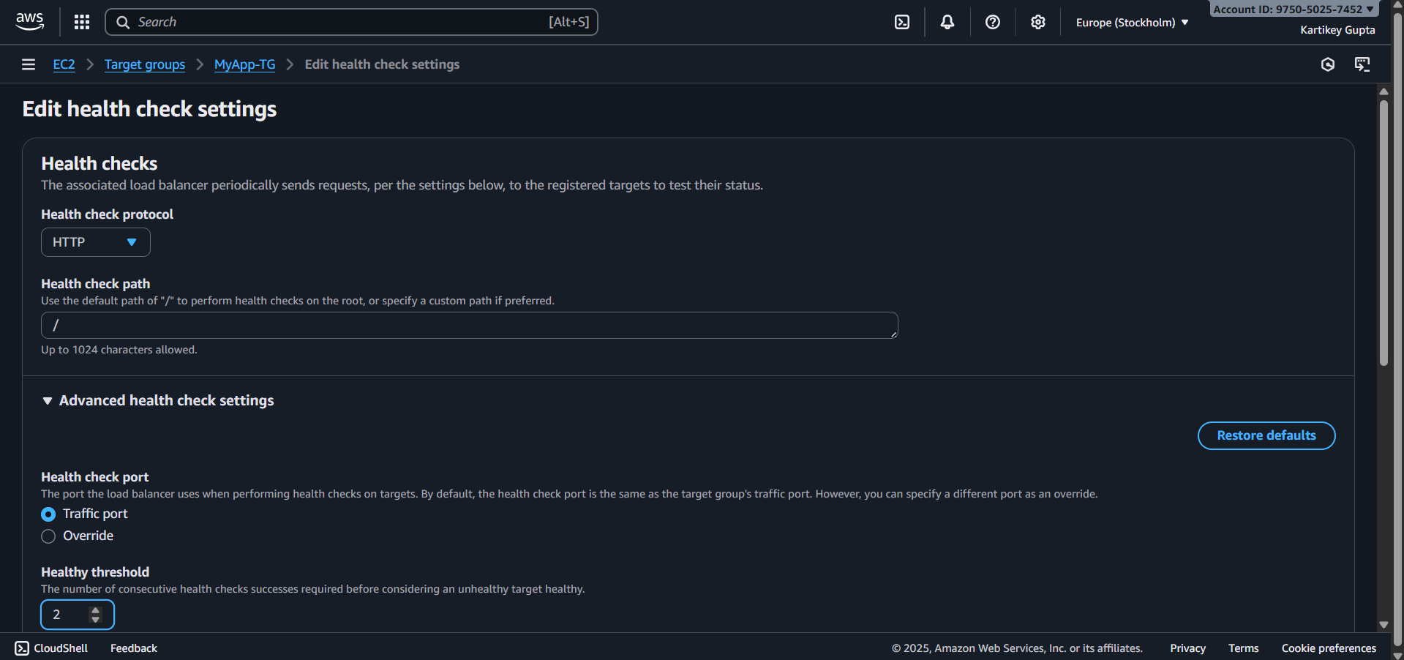
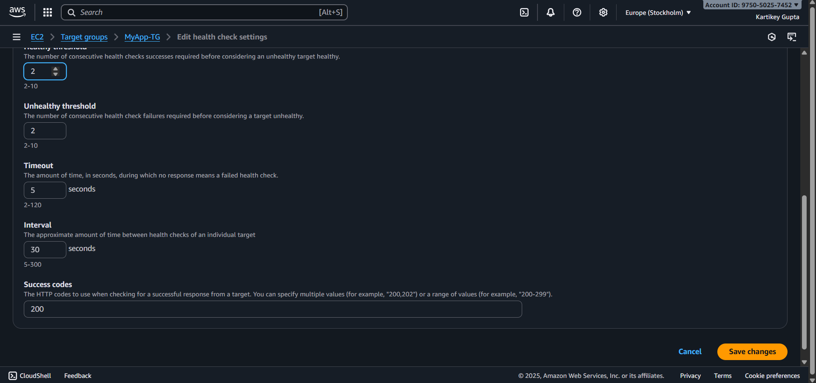

Step 4: Save
- Click Save to apply health check settings.

Step 5: Verify
- Go back to Targets tab in the Target Group.
- After a few seconds/minutes, the Status column should show healthy for your EC2 instances.
- If an instance fails, check:
  - Security group allows inbound HTTP from ALB
  - Web server is running and responding at the path you configured
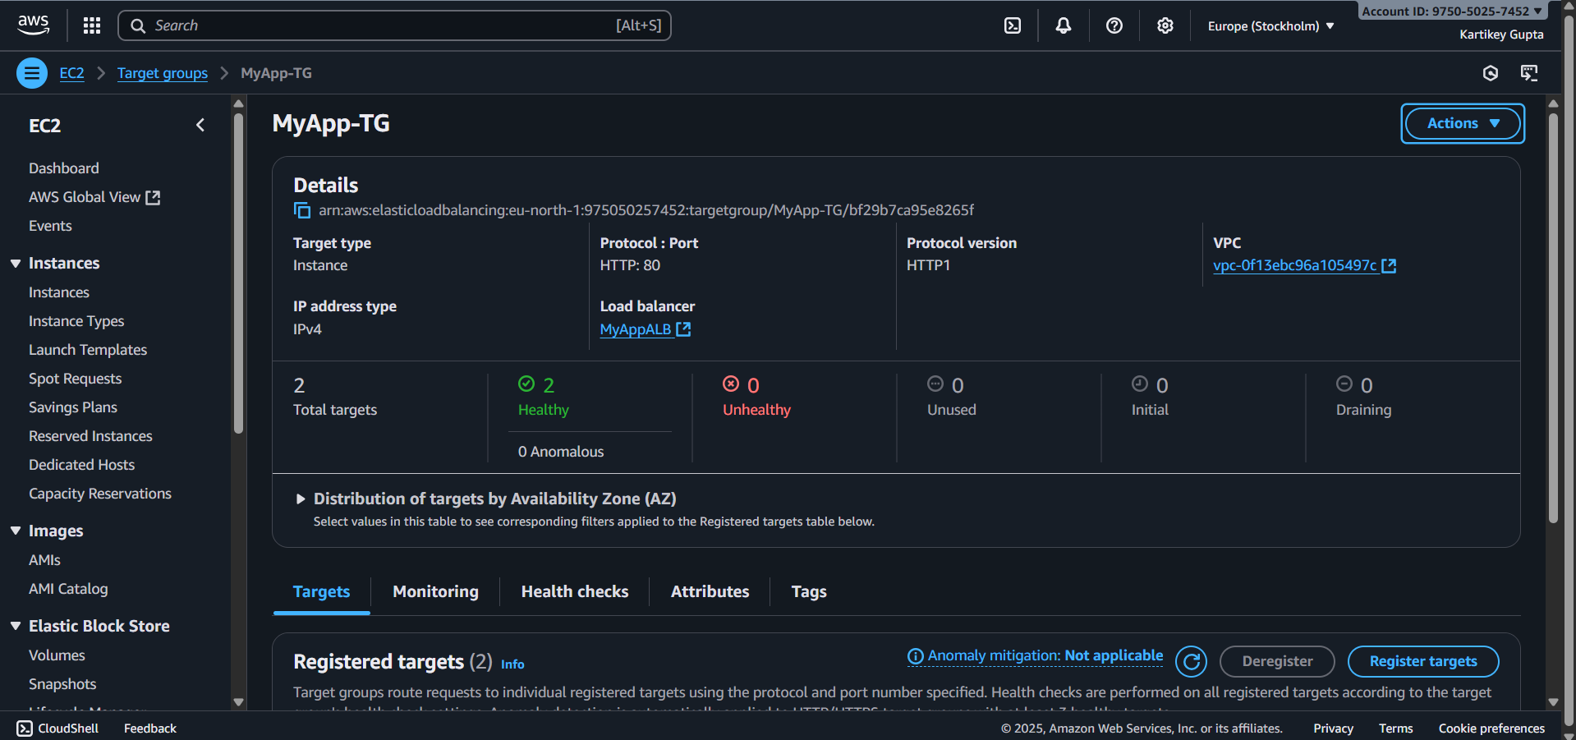

Step (iv): Enable Auto Scaling
Step 1: Prepare a Launch Template
- Go to EC2 → Launch Templates → Create Launch Template.
- Configure template:
  - Name: MyApp-LT
  - AMI: Use the same AMI as your EC2 instances
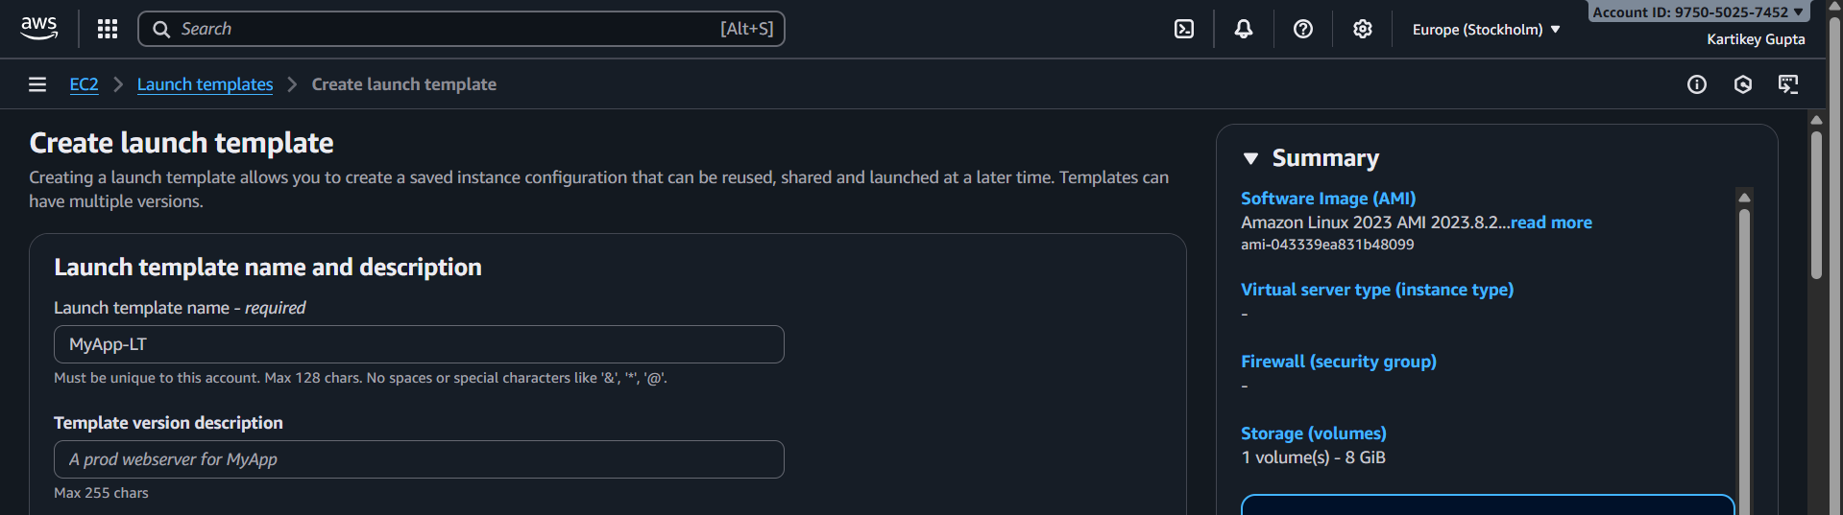
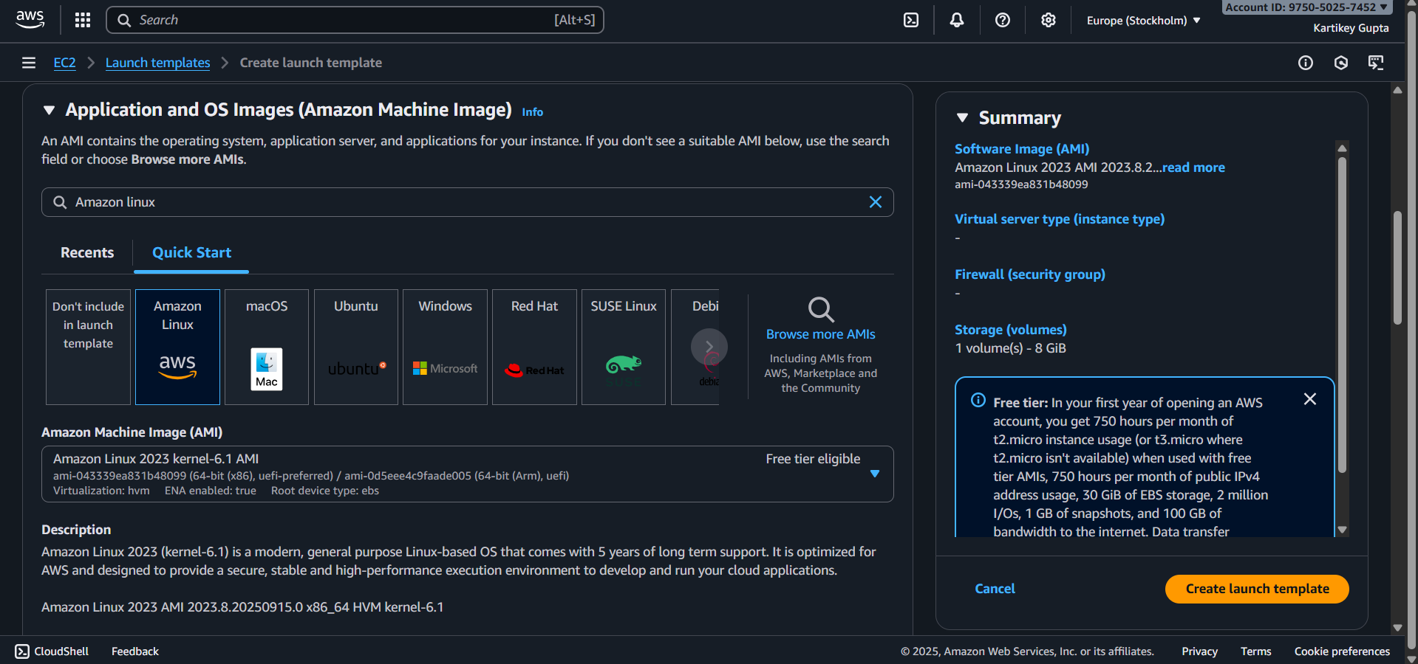
  - Instance type: e.g., t2.micro
  - Key pair: Your existing key
  - Security group: Same as your running EC2 (allow HTTP 80 from ALB SG)
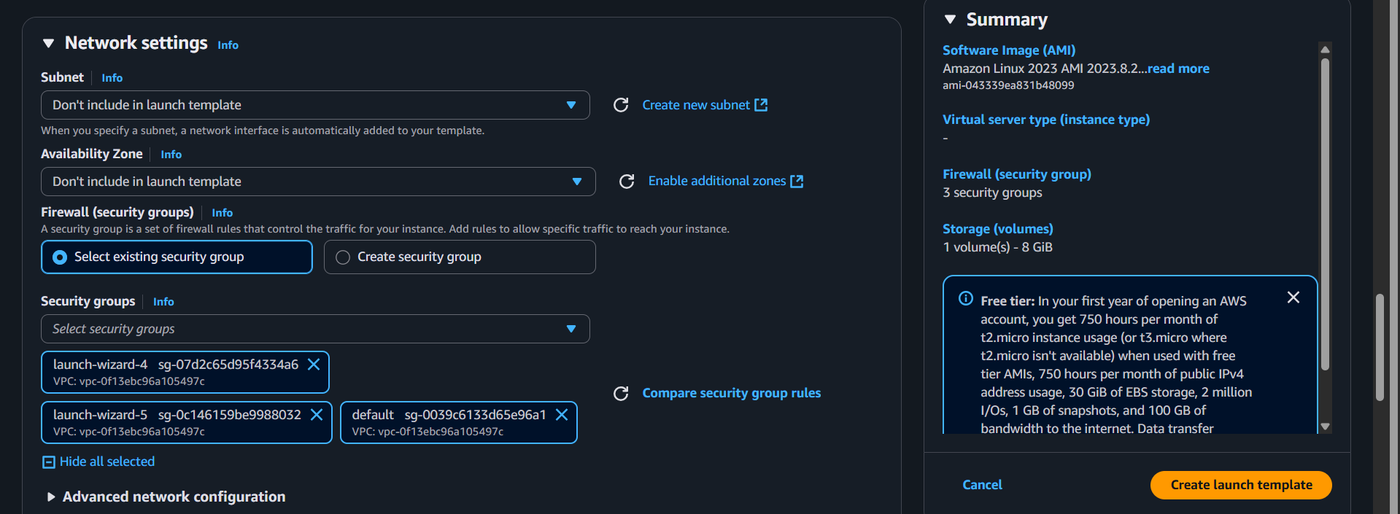
  - User data (optional): Script to auto-install Apache/web server on launch:
#!/bin/bash
yum update -y
yum install -y httpd
systemctl start httpd
systemctl enable httpd
echo "Hello from $(hostname -f)" > /var/www/html/index.html
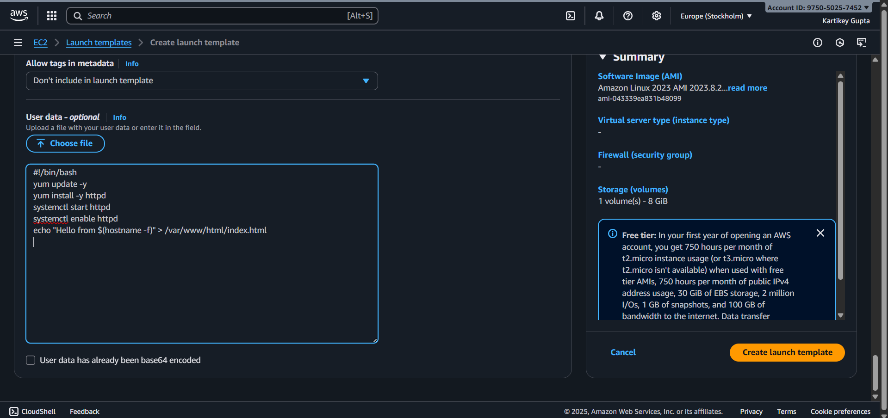

- Save the Launch Template.
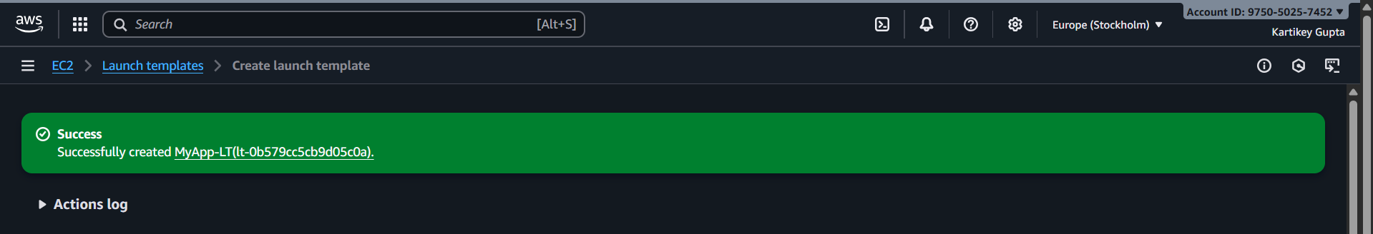

Step 2: Create Auto Scaling Group
- Go to EC2 → Auto Scaling Groups → Create Auto Scaling Group.
- Select launch template: MyApp-LT
- Name: MyApp-ASG
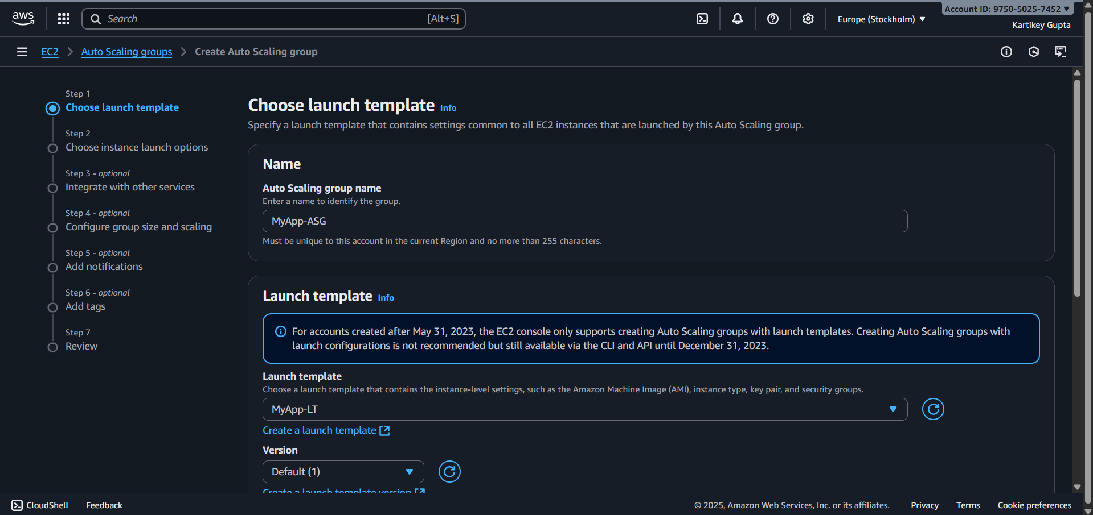

Step 3: Configure Network
- VPC: Same as your instances/ALB
- Subnets: Select at least 2 AZs for high availability
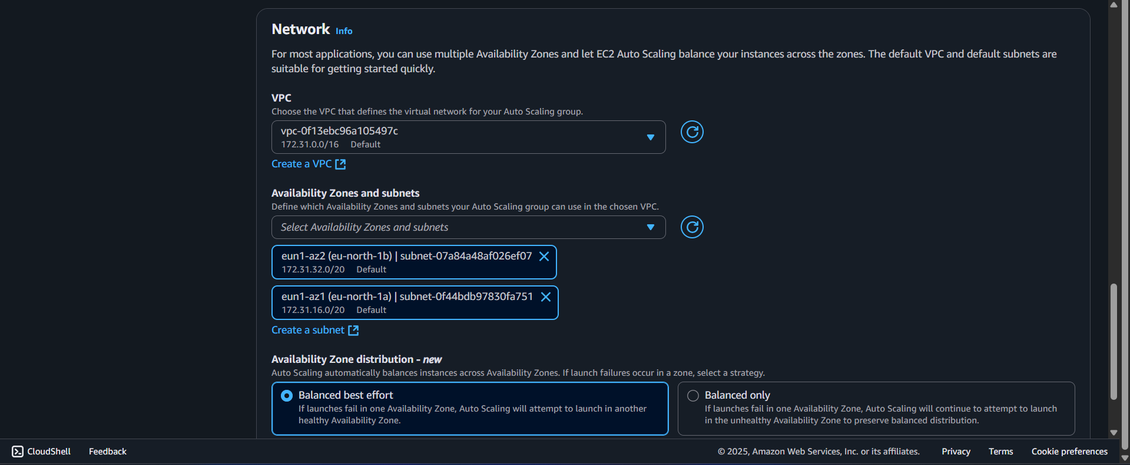

Step 4: Attach to Target Group
- Select “Attach to an existing load balancer”
- Choose your ALB Target Group (MyApp-TG)
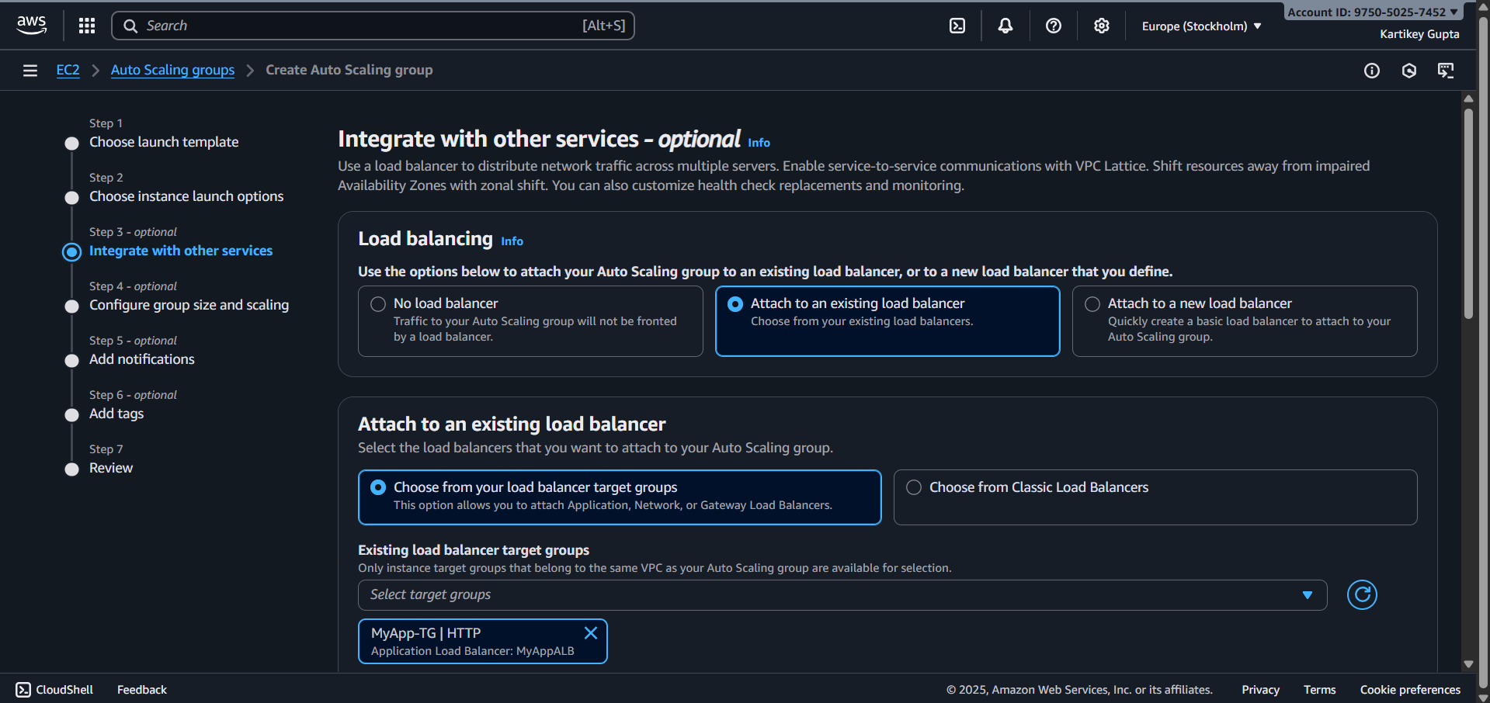

Step 5: Configure Group Size
- Desired capacity: 2 → initially 2 instances
- Minimum: 2 → ensures at least 2 instances are always running
- Maximum: 5 → allows scaling up to 5 instances if needed
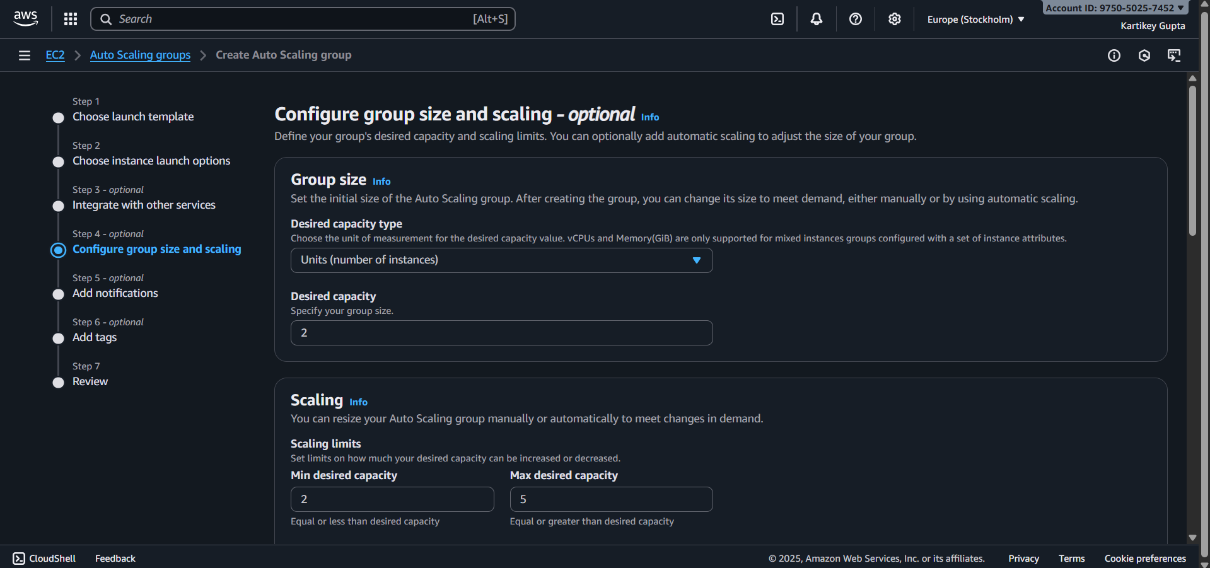
Step 6: Add Scaling Policies
- Target tracking / simple scaling
- Example policy:
  - Scale out: CPU > 70% → add instance(s)
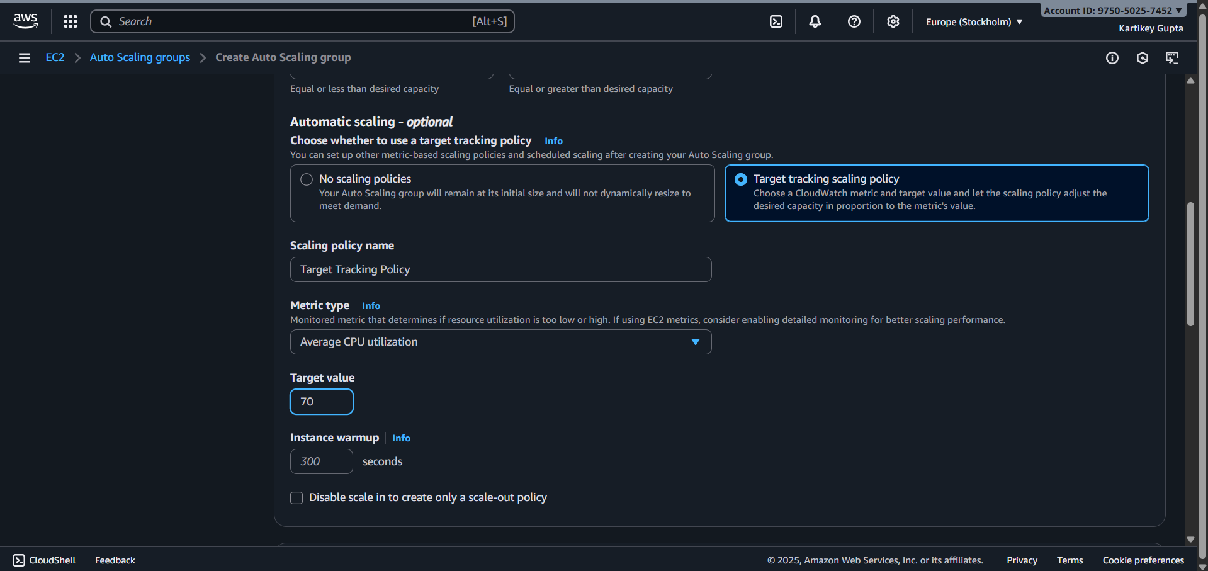
Step 7: Review and Create
- Review all settings → click Create Auto Scaling Group
- Auto Scaling will now automatically launch 2 instances initially, register them with ALB, and scale based on traffic.
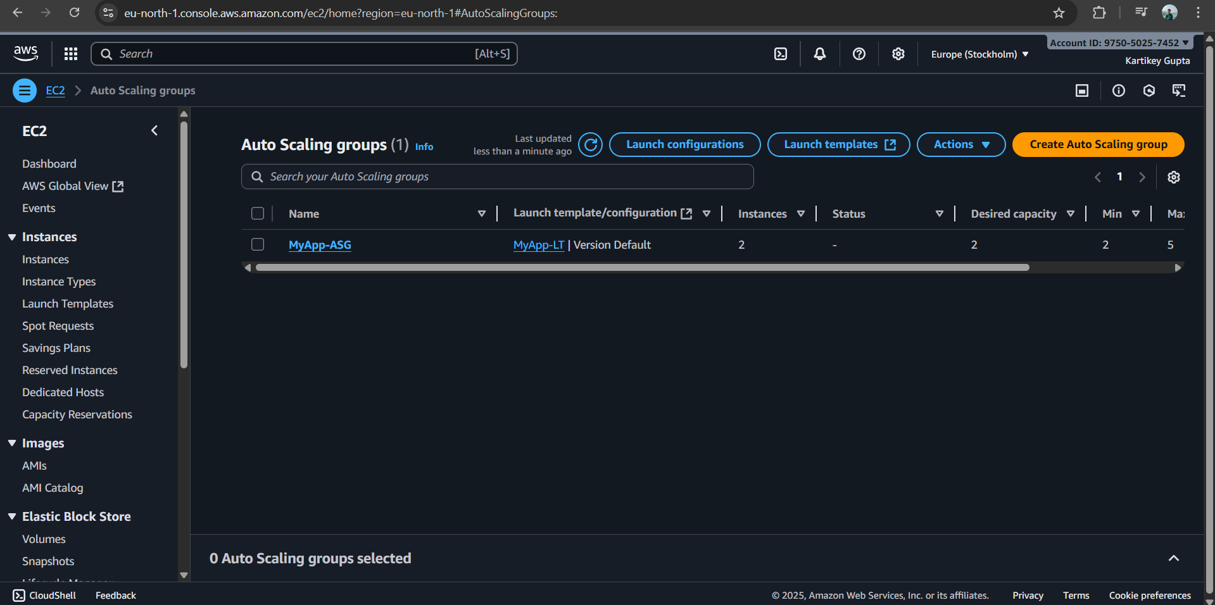
(v) Configure Path-Based Routing + Route 53
- Go to ALB → Listeners → View/Edit rules.
- Add rules:
  - If path is /auth → forward to Target Group: AuthService.
  - If path is /order → forward to Target Group: OrderService.
- Ensure you created separate EC2 groups (Auth, Order) running respective services.
- Save listener rules.
